**Main Details:**

* **Repos:**
  + [**Task Board**](https://github.com/users/jusbuckingham/projects/2)
  + [**Frontend**](https://github.com/jusbuckingham/ga-list)
  + [**Backend**](https://github.com/jusbuckingham/ga-list-api)
* **Team Members:** 
  + Kyle Kallman - Frontend Engineer Lead
  + Mikalai Bertman - Full Stack Engineer
  + Jus Buckingham - Backend Engineer / Project Manager
* **Team Name:**
  + ga-list
* **Elevator Pitch:**
  + “Thee marketplace for all of your browsing needs. For GA, by GA!”
* **User Story:**
  + As a user I want to…
    - Access the home page.
    - To browse listings.
    - To log in (optional).
    - To create and manage my own posts.
  + Additional details
    - Who this is for:
    - What this is for:
    - Why:
* **Tech Stack**:
  + MERN
* **Status Of Project:**
  + Building in progress
* **Sprint Schedule:**
  + Day 1 - Planning | Build Out Models
  + Day 2 - Planning | Restructuring user story and models.
  + Day 3 - Adding ‘comments’ model and schema to the backend | Working on building out the front end react app.
  + Day 4 - Building out controllers and seeding data | Building out frontend routes & other styling.
  + Day 5 - Complete authentication communication between front & backend | Start making tests for react components | Working on UI
  + Day 6 - Get controllers working with full CRUD on the backend | Create Tests For The Frontend Components | Complete front end UI | Build Out Readmes for both repos | Confirm everybody can use both repos with no errors
  + Day 7 (Last Day) - Deploy Frontend and make sure app works | Make some last minute cosmetic changes | Complete readmes for both repo

**App Details:**

**Frontend:**

* **Routes:**
  + Home
  + Community
  + Housing
  + Jobs
  + Discussion Forum
* **Components:**
  + User
  + Sale Item
  + Job Posting
  + Forum Topic
  + Home
  + Comments
  + Individual listing
  + Container of listings
  + Contact form

**Backend:**

* **Models:** 
  + Users
    - Schemas used:
      * Users
  + Posts
    - Schemas used:
      * Comments
      * Posts
  + Jobs:
    - Schemas used:
      * Jobs
  + Sales:
    - Schemas used:
      * Sales
  + Forums:
    - Schemas used:
      * Forums
  + Comments
    - Schemas used:
      * Comments

* **Schemas:**
  + Users
    - name: string
    - email: string
    - password: string
    - timesLoggedIn: number
    - date: date
  + Sales
    - title: string
    - description: string
    - price: string
    - contact_info: string
    - location: string (MAP API?)
    - image_url: string
  + Jobs
    - title: string
    - description: string
    - payment: string
    - contact_info: string
    - location: string (MAP API?)
  + Forums
    - title: string
    - post_text: string
    - user_name: string
    - likes: string
    - comments: string
  + Post
    - title: string
    - body: string
    - comments: string
  + Comments
    - header: string
    - content: string
    - date: string
* **APIs:**
  + ga-list API
  + Third Party (Map API?)

**WIREFRAMES:**

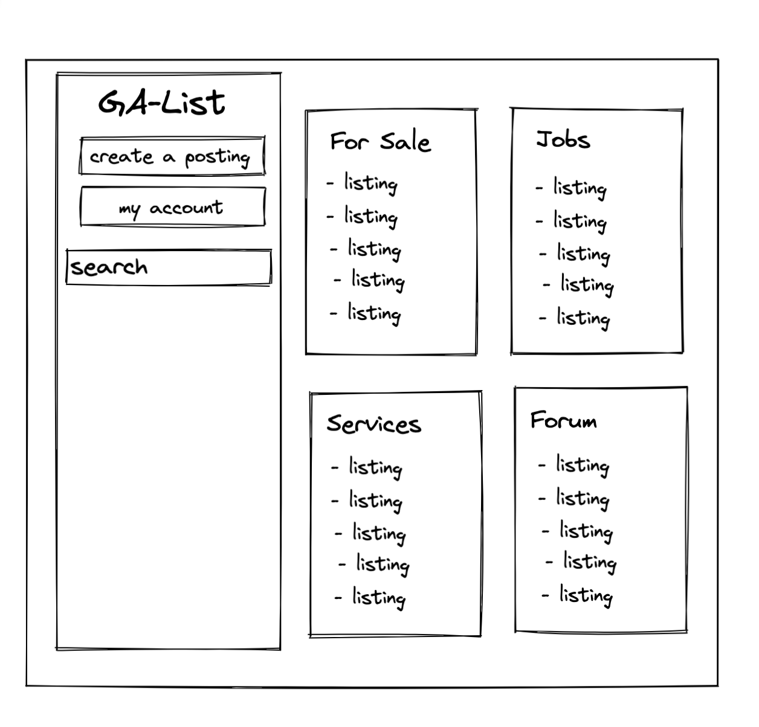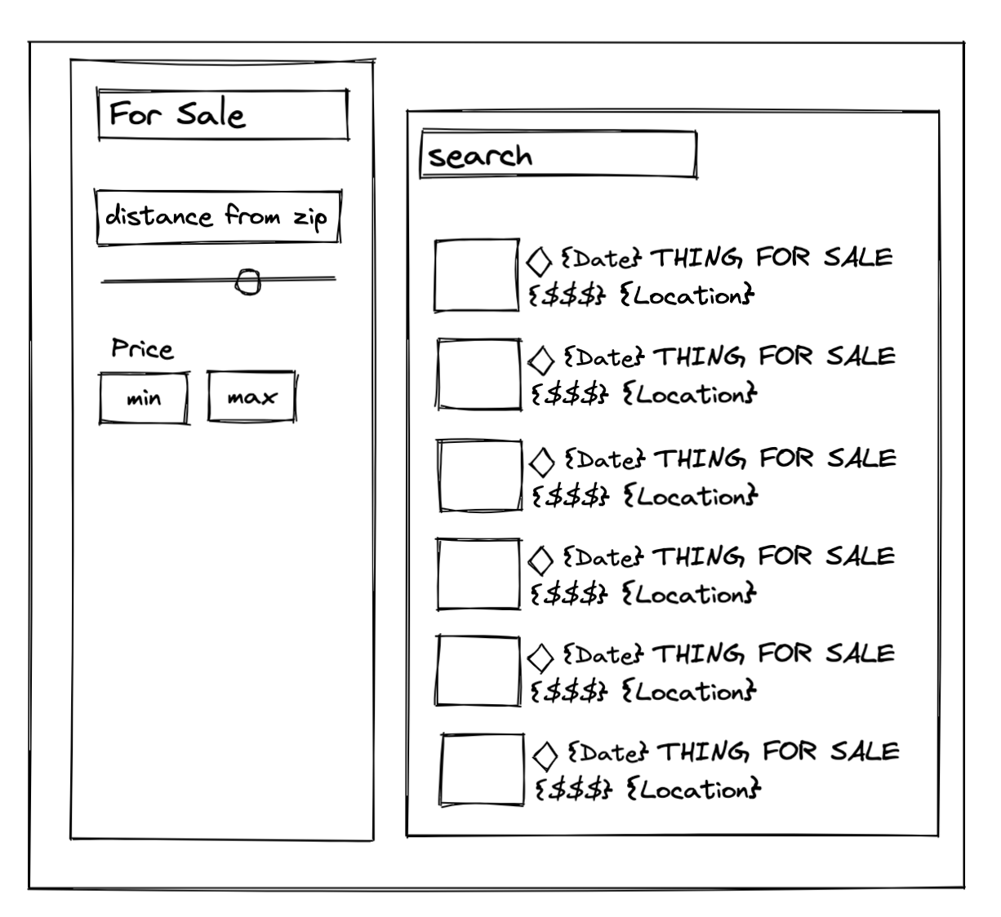

Data CRUD

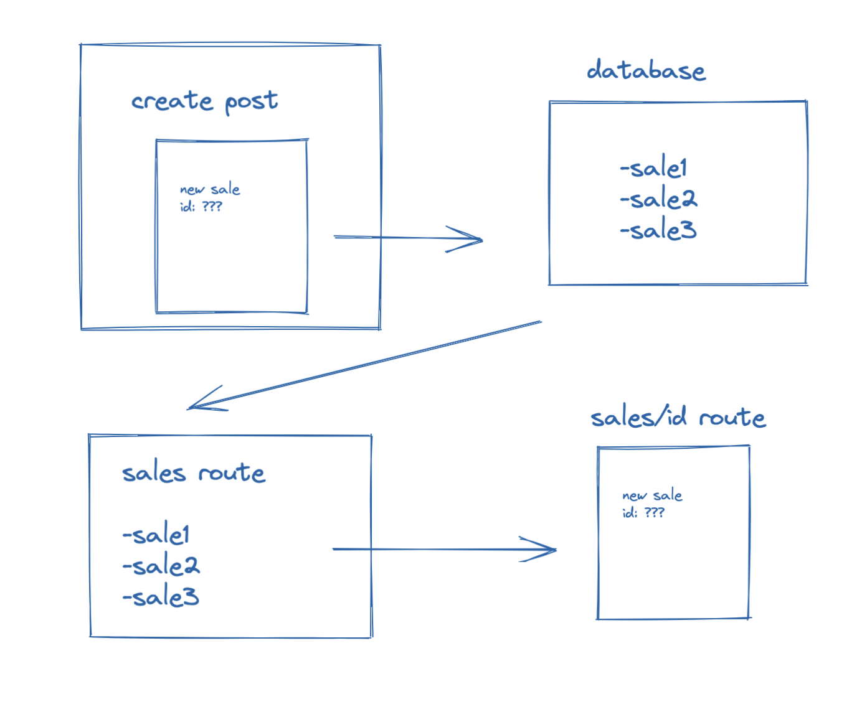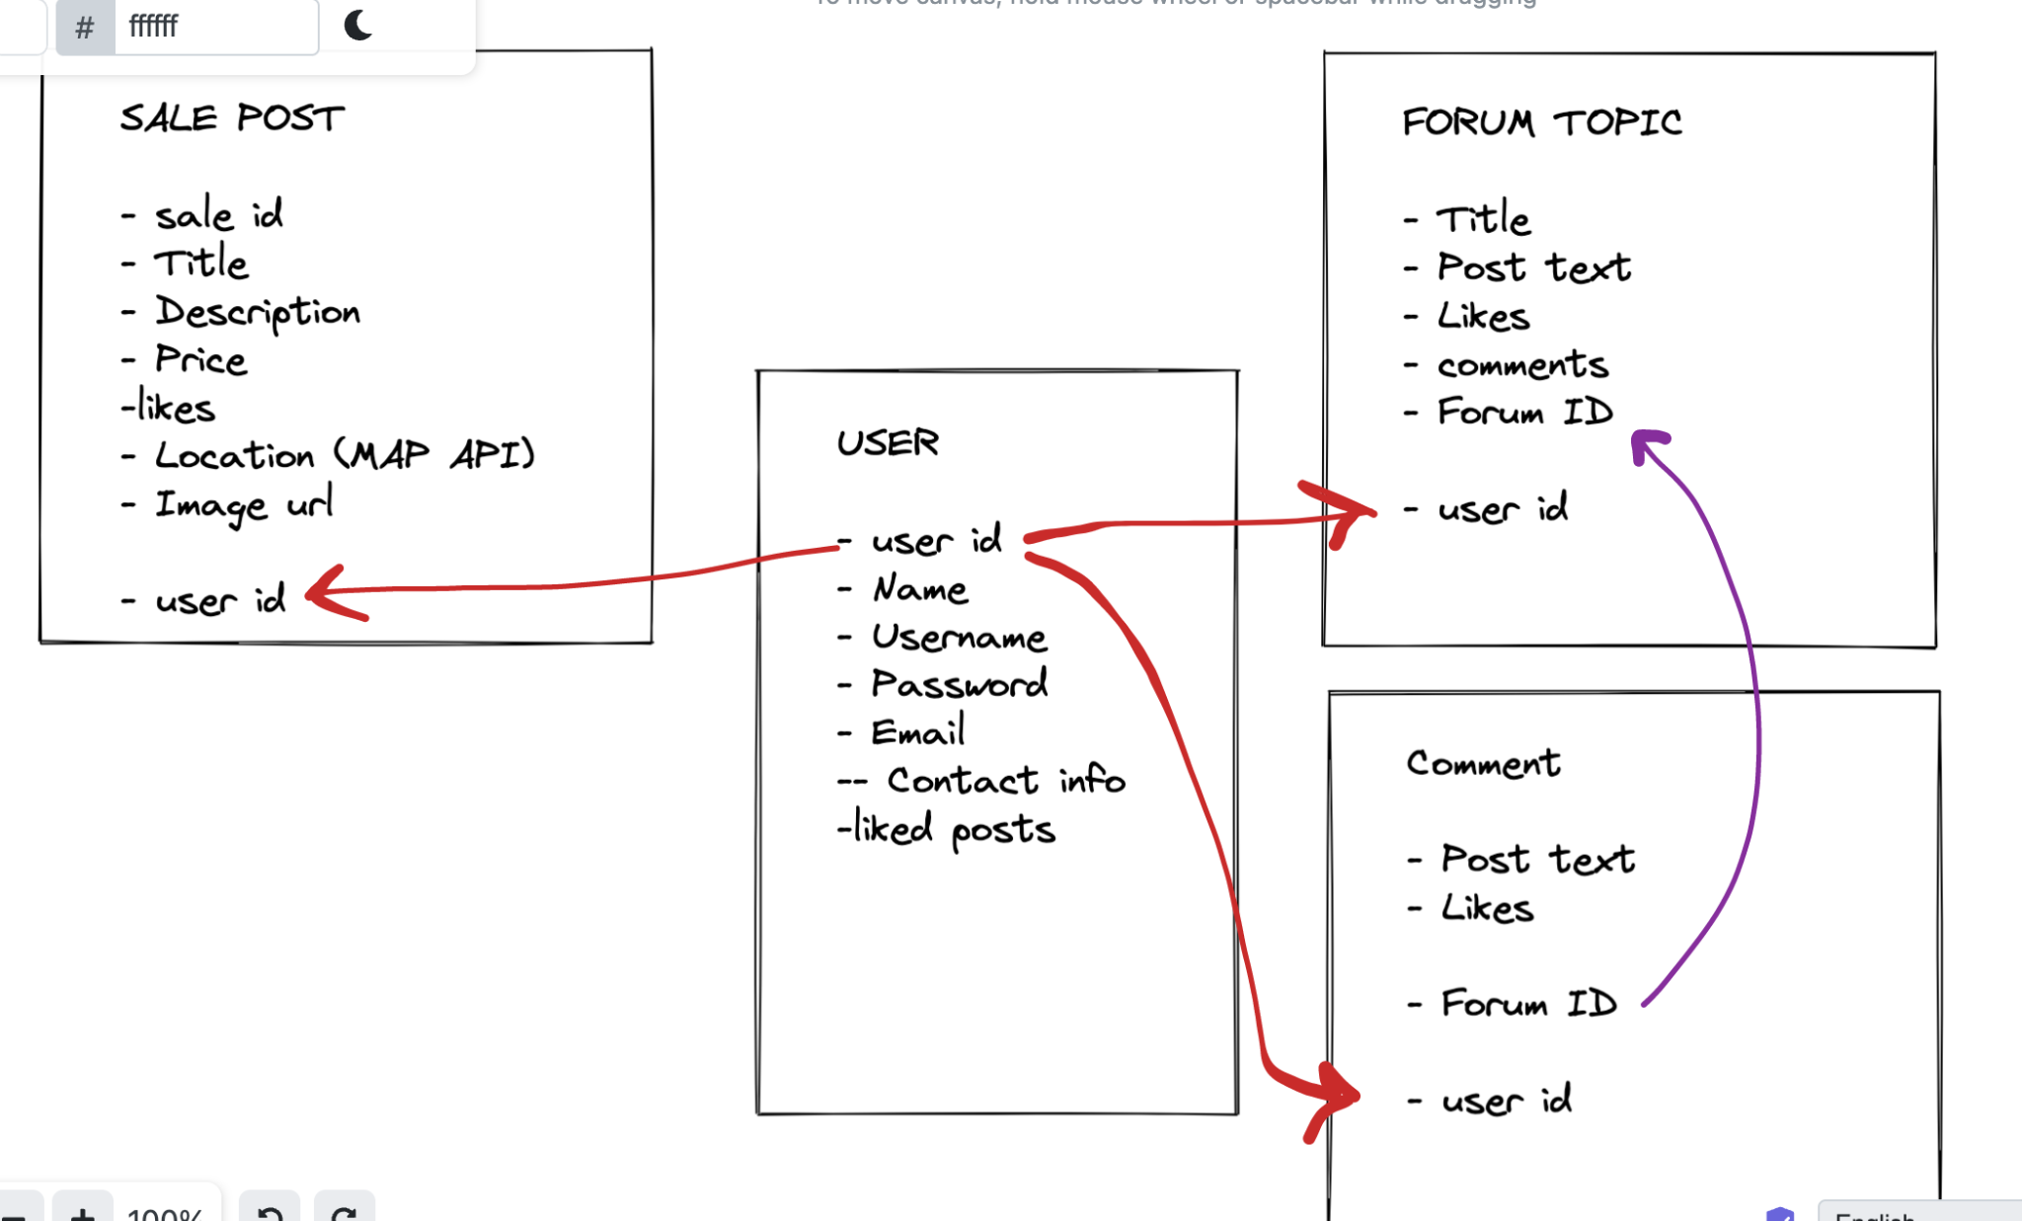

**STRETCH GOALS:**

* Users
* Comments

**Necessary Deliverables:**

* A working app, built by the whole team, hosted somewhere on the internet
* A link to your hosted working app in the URL section of your Github repo
* A team git repository hosted on Github, with a link to your hosted project, and frequent commits from *every* team member dating back to the *very beginning* of the project.
* A readme.md file with:
  + Include a screenshot of the site in repo's README
  + Explanations of the technologies used
  + A couple paragraphs about the general approach you took
  + Installation instructions for any dependencies
  + Link to your user stories – who are your users, what do they want, and why?
  + Link to your wireframes – sketches of major views / interfaces in your application
  + Descriptions of any unsolved problems or major hurdles your team had to overcome.

**Front End gameplan:**

* **Create react app**
* **Build main components** 
  + **Front page**
  + **User page**
  + **Post**

**PROBLEMS/BLOCKERS:**

* **Figuring out efficient schemas**
* **Careful planning**
* **Communicating between front end and backend**

**What we did (on resume:**

* **Testing, wrote over 100 tests for MERN app**